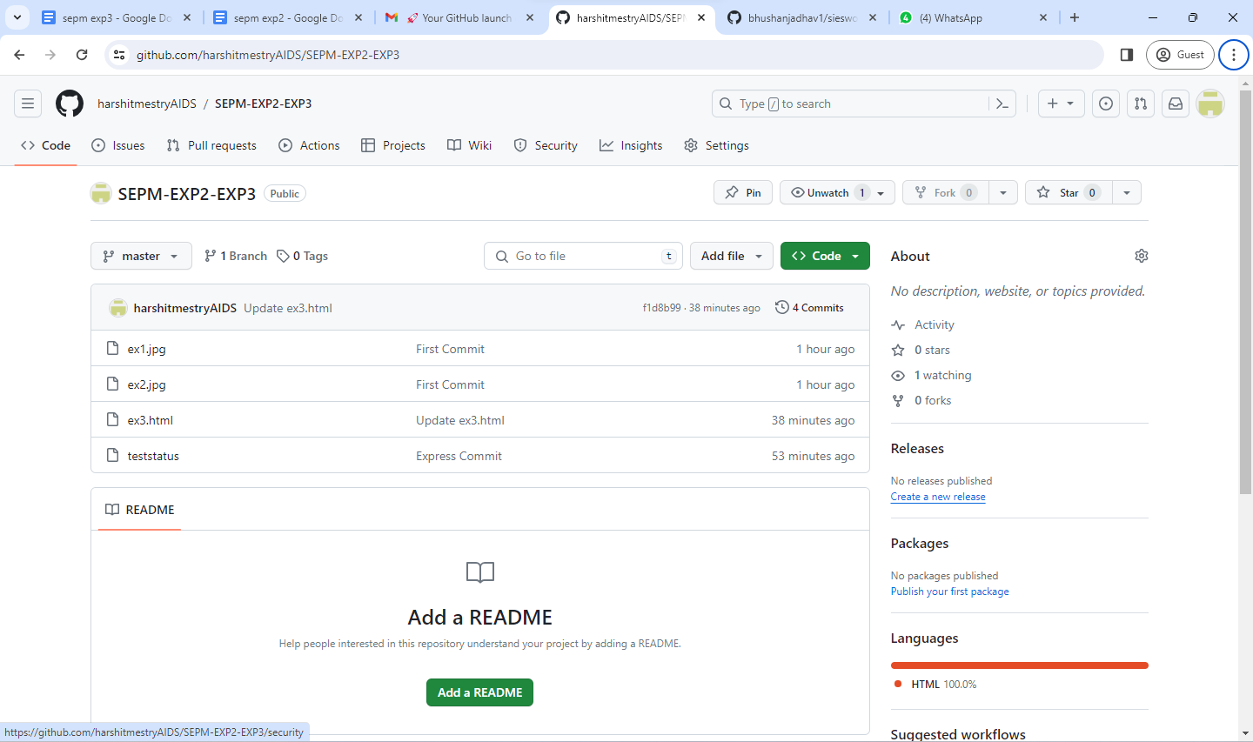

AI&DS 202@DESKTOP-8MGF9NT MINGW64 ~/t21-73/git-dvcs/git-demo-project (master)

**$ git clone https://github.com/bhushanjadhav1/siesworkshop.git**

Cloning into 'siesworkshop'...

remote: Enumerating objects: 12, done.

remote: Counting objects: 100% (12/12), done.

remote: Compressing objects: 100% (9/9), done.

remote: Total 12 (delta 0), reused 10 (delta 0), pack-reused 0

Receiving objects: 100% (12/12), done.

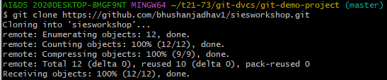

AI&DS 202@DESKTOP-8MGF9NT MINGW64 ~/t21-73/git-dvcs/git-demo-project (master)

**$ ls**

ex1.jpg ex2.jpg ex3.html siesworkshop/ teststatus



AI&DS 202@DESKTOP-8MGF9NT MINGW64 ~/t21-73/git-dvcs/git-demo-project (master)

**$ git remote add origin** [**https://github.com/harshitmestryAIDS/exp1.git**](https://github.com/harshitmestryAIDS/exp1.git)



AI&DS 202@DESKTOP-8MGF9NT MINGW64 ~/t21-73/git-dvcs/git-demo-project (master)

**$ git remote show origin**

* remote origin

Fetch URL: https://github.com/harshitmestryAIDS/exp1.git

Push URL: https://github.com/harshitmestryAIDS/exp1.git

HEAD branch: (unknown)

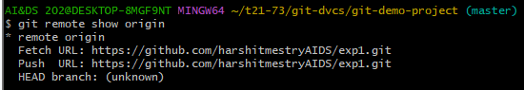

AI&DS 202@DESKTOP-8MGF9NT MINGW64 ~/t21-73/git-dvcs/git-demo-project (master)

**$ git push -u origin master**



AI&DS 202@DESKTOP-8MGF9NT MINGW64 ~/t21-73/git-dvcs/git-demo-project (master)

$ git push -u origin master

Enumerating objects: 9, done.

Counting objects: 100% (9/9), done.

Delta compression using up to 12 threads

Compressing objects: 100% (8/8), done.

Writing objects: 100% (9/9), 10.72 KiB | 10.72 MiB/s, done.

Total 9 (delta 2), reused 0 (delta 0), pack-reused 0

remote: Resolving deltas: 100% (2/2), done.

To https://github.com/harshitmestryAIDS/exp1.git

* [new branch] master -> master

branch 'master' set up to track 'origin/master'.

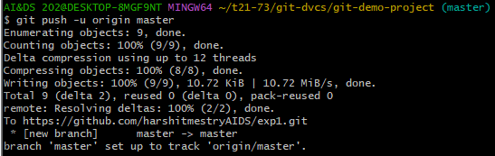

AI&DS 202@DESKTOP-8MGF9NT MINGW64 ~/t21-73/git-dvcs/git-demo-project (master)

**$ git pull**

Already up to date.



AI&DS 202@DESKTOP-8MGF9NT MINGW64 ~/t21-73/git-dvcs/git-demo-project (master)

**$ git log --oneline origin/master**

04c9b93 (HEAD -> master, origin/master) Express Commit

d2c1321 Express Commit

ae06ff4 First Commit

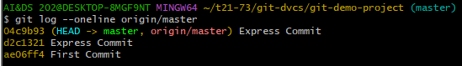

AI&DS 202@DESKTOP-8MGF9NT MINGW64 ~/t21-73/git-dvcs/git-demo-project (master)

**$ git fetch**

remote: Enumerating objects: 5, done.

remote: Counting objects: 100% (5/5), done.

remote: Compressing objects: 100% (2/2), done.

remote: Total 3 (delta 1), reused 0 (delta 0), pack-reused 0

Unpacking objects: 100% (3/3), 915 bytes | 48.00 KiB/s, done.

From https://github.com/harshitmestryAIDS/exp1

04c9b93..f1d8b99 master -> origin/master

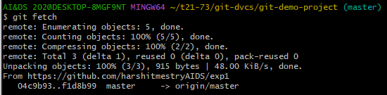

AI&DS 202@DESKTOP-8MGF9NT MINGW64 ~/t21-73/git-dvcs/git-demo-project (master)

**$ git log --oneline origin/master**

f1d8b99 (origin/master) Update ex3.html

04c9b93 (HEAD -> master) Express Commit

d2c1321 Express Commit

ae06ff4 First Commit

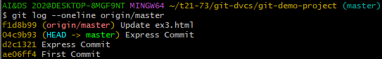

AI&DS 202@DESKTOP-8MGF9NT MINGW64 ~/t21-73/git-dvcs/git-demo-project (master)

**$ cat ex3.html**



AI&DS 202@DESKTOP-8MGF9NT MINGW64 ~/t21-73/git-dvcs/git-demo-project (master)

**$ git merge**

Updating 04c9b93..f1d8b99

Fast-forward

ex3.html | 1 +

1 file changed, 1 insertion(+)

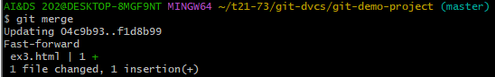

AI&DS 202@DESKTOP-8MGF9NT MINGW64 ~/t21-73/git-dvcs/git-demo-project (master)

**$ cat ex3.html**

hello



